**Figure A1.1 – Stratified Programmes**

**i. Risk-1 & Masking**

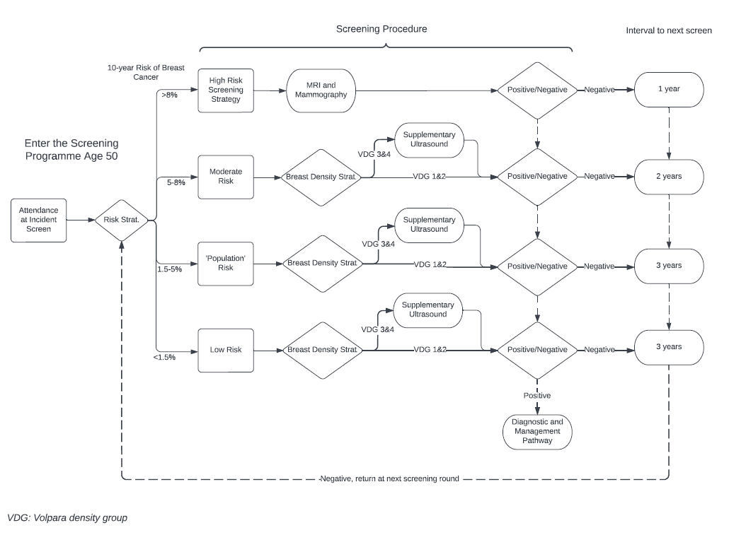

**Figure A1.1 – Stratified Programmes**

**ii. Risk-1**

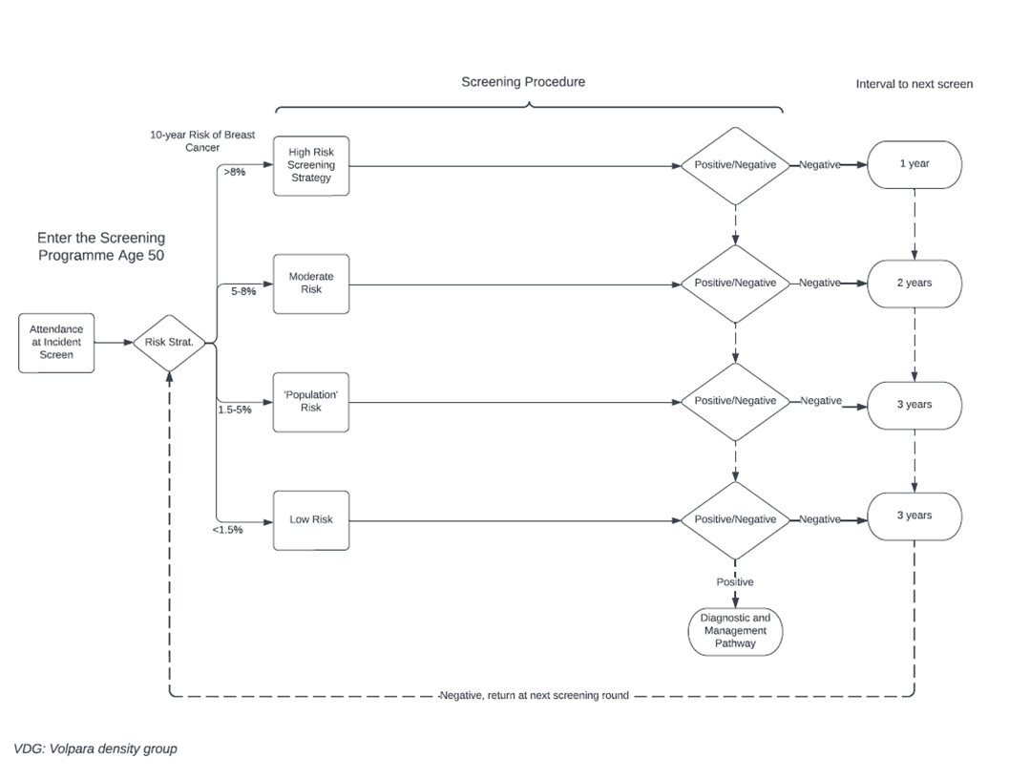

**Figure A1.1 – Stratified Programmes**

**iii. Risk-2**

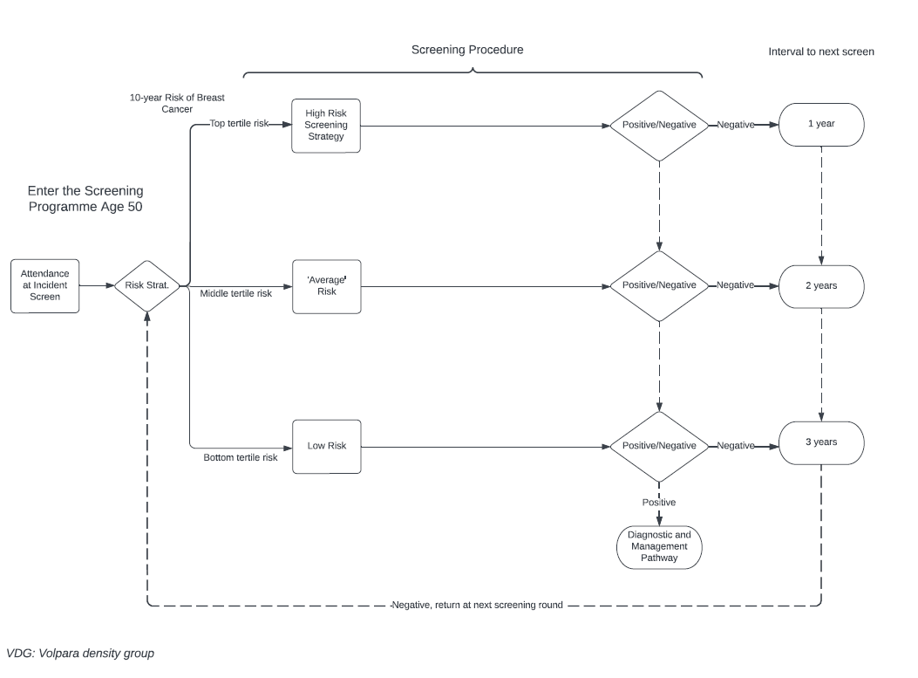

**Figure A1.1 – Stratified Programmes**

**iv. Masking**

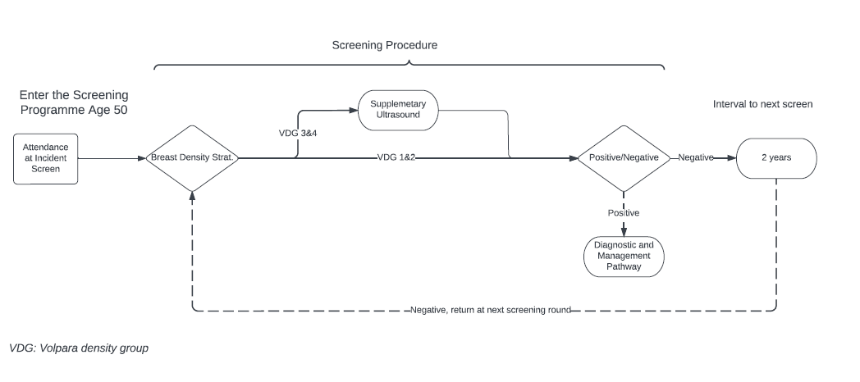

Figure A1.2: Breast cancer natural history and screening

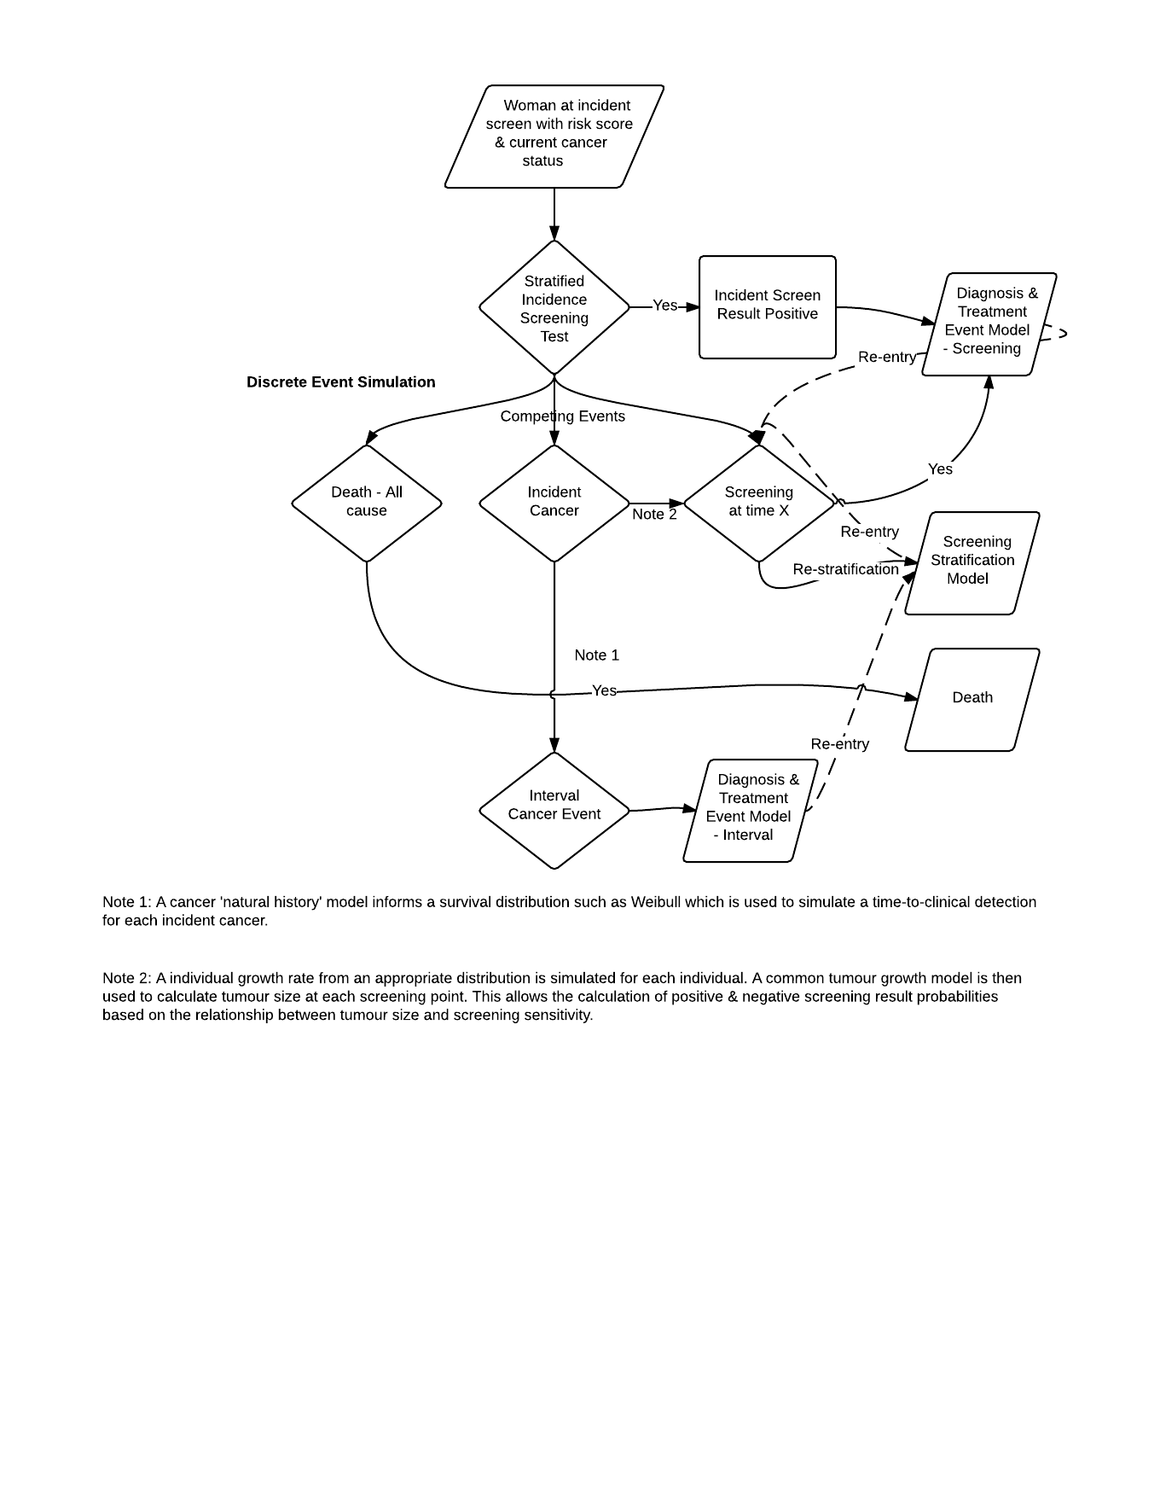

Figure A1.3: Diagnosis and treatment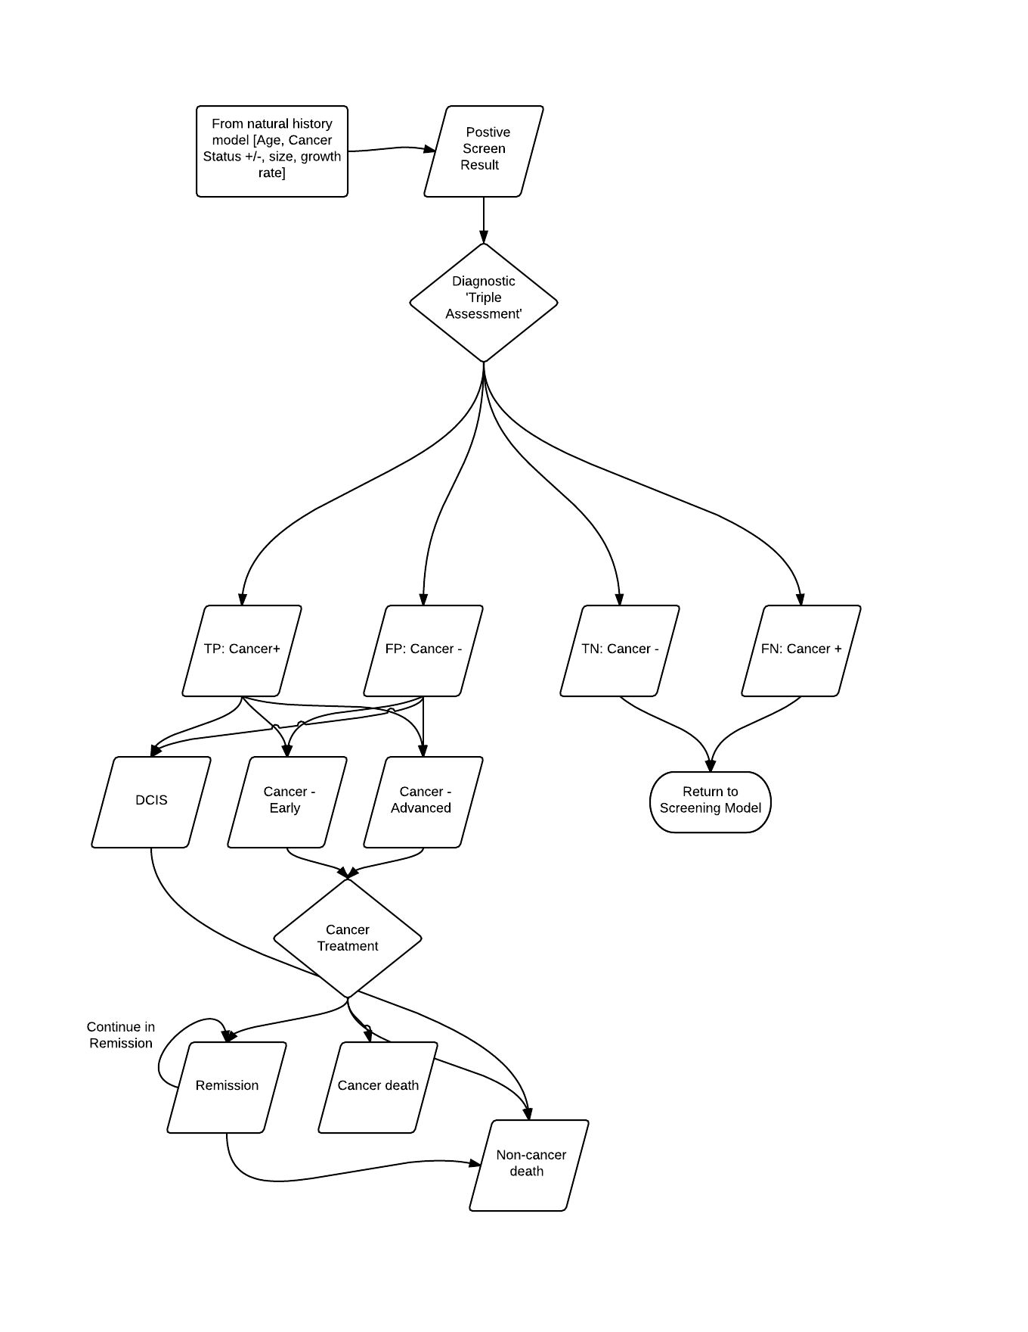

*TP: true positive*

*FP: false positive*

*DCIS: ductal carcinoma in situ*